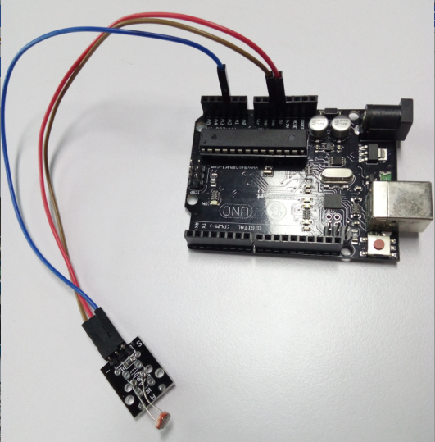

int sensorPin = 2;

int value = 0;

void setup () {

Serial.begin (9600);

}

void loop () {

value = analogRead (sensorPin);

Serial.println (value, DEC);

delay (50);

}